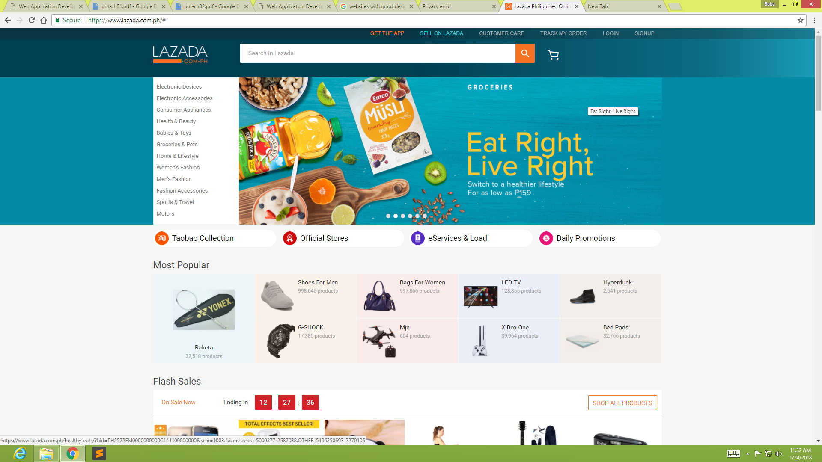
Logo
Same Color
This part remains constant when changing pages
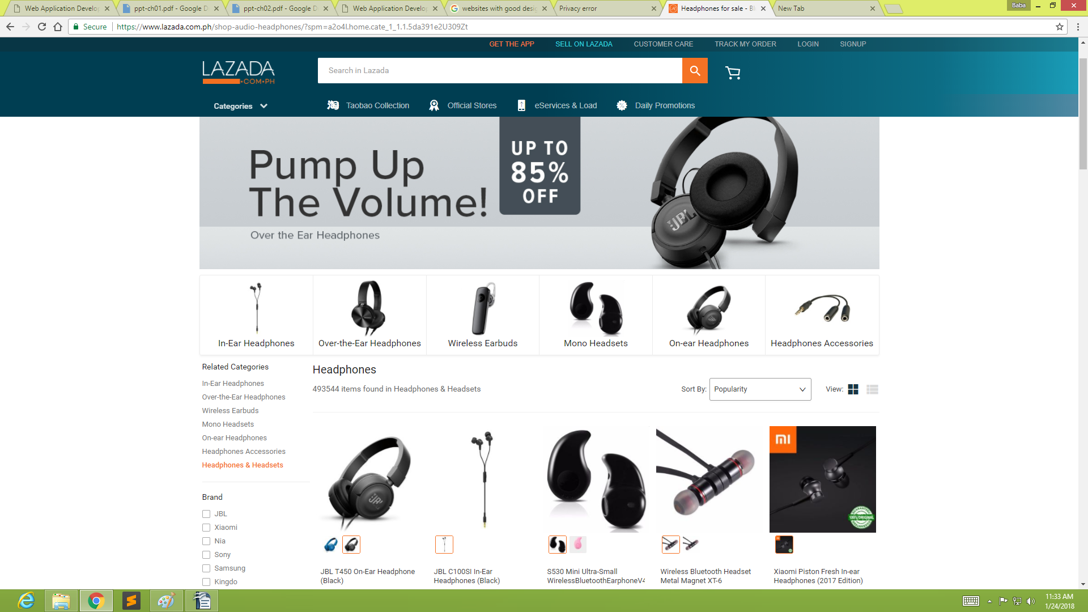
Inactive space
Active space
Fixed Columns
Content fixed into one display area
The web pages selected, both have in common the Logo name, Search bar, and other menu selection at the top of the page. The difference is, when selecting a secondary topic, it enters into a new page and shows other features of the website. This web page has a grid type view where, the user can view the main head of the the page then scroll down to see the other content in a grid type manner.

The website has white spaces, although the website has good design, it can expand its content to the outer parts of the white spaces so that more content can be shown. Also the catagories can be placed to the white spaces so that it can be more useful.

Browse the Web for examples of poor Web design on mainstream Web sites.
- Using a screen-capture program, capture Web pages from the Web site that show two levels of information. For example, capture the main page of a Web site and a s econdary page.
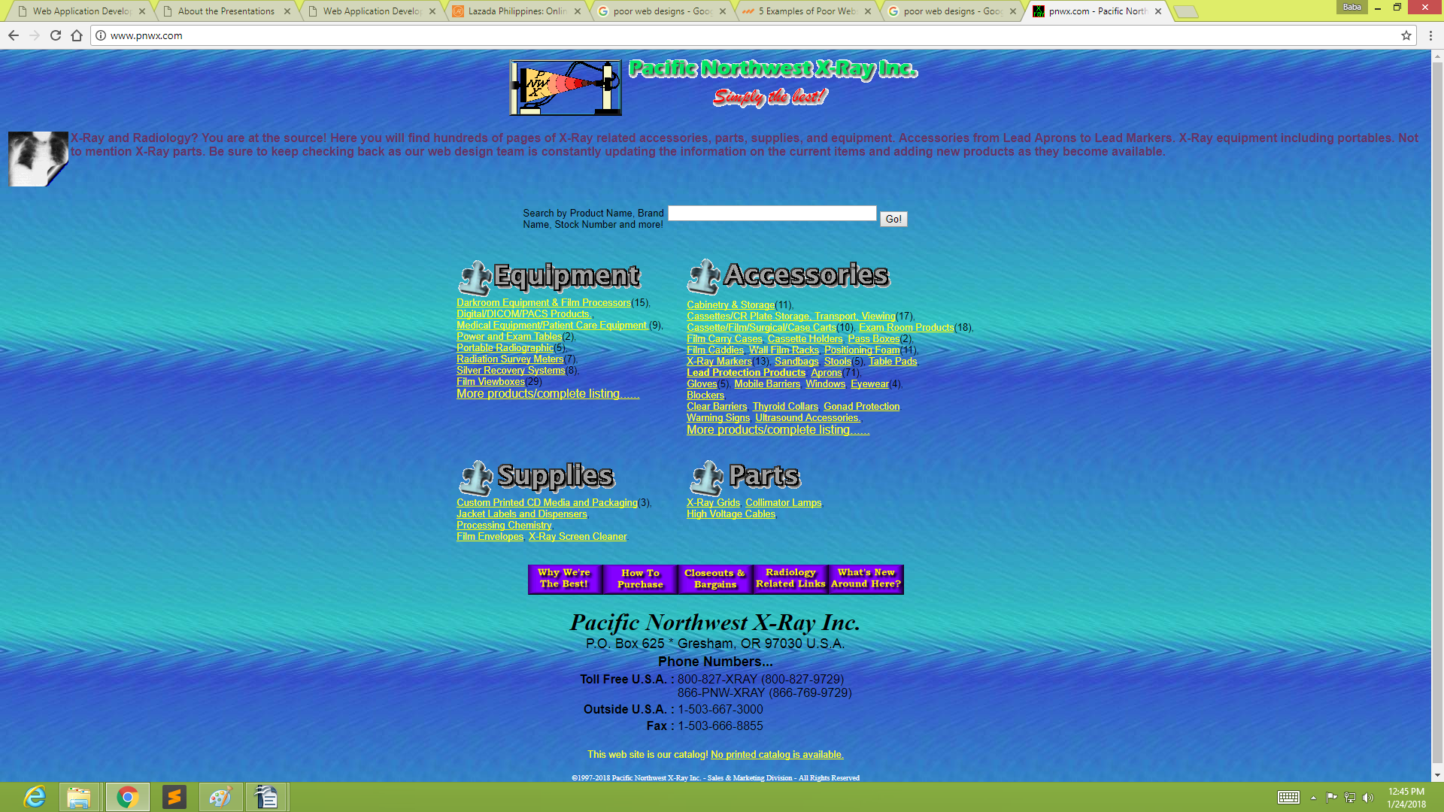
Colors not match well
Header not well presented
Difficult to identify the logo
Colors not contrasting well to the background
Details can be on a seperate page
Better layout of the Content
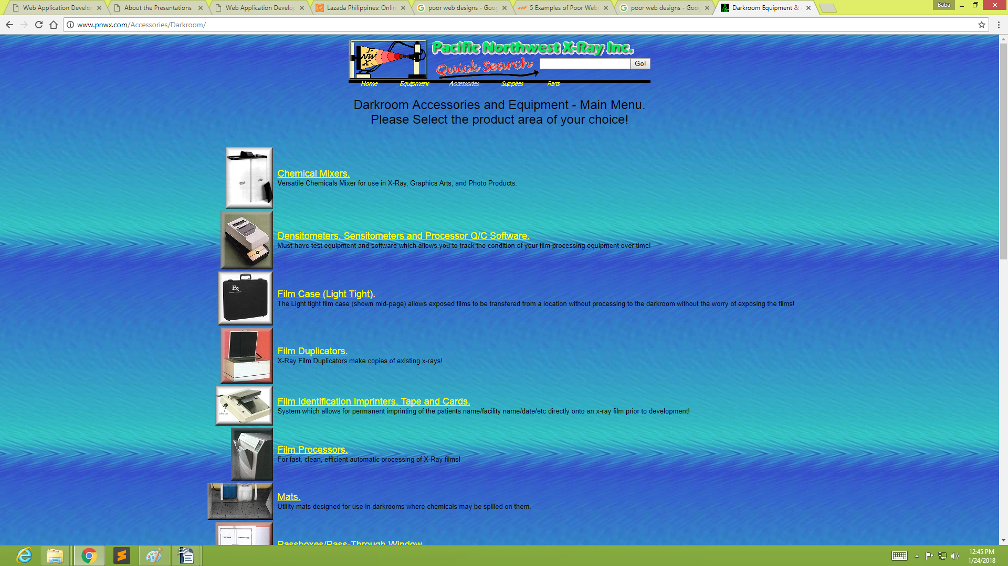
Inactive spaces
Search bar not consistant
Images could be bigger
Larger letters
- Indicate with screen callouts the jarring or distracting inconsistencies of the site, such as abrupt changes in any design elements, including theme and layout.

- List detailed recommendations for improving the site design.
My Recomendations for this particular site is, to change the layout of the website. Prefered layout is Paperbased reading, this is based on the different types of content that will be displayed and layed out easily.
Set the main catagories for the website on the top part of the page. Then the other content can be easily placed into the other pages.
the layout of the other pages in the other pages should be consistant and has limited white surroundings.

Write a short essay critiquing a Web sites design. Describe the structural layout of the site and determine whether information is presented clearly and is easily accessible.
The websites are ment to catch the users attention when entering them. Providing users with a friendly environment and also a good structural layout of the site itself. Some sites can be very good in displaying their content while others can be done just out of limited resources.
In todays technological world, there are advanced and yet simple to use softwares that can help build up newer and better interactive websites so that users can be able to enjoy and feel more informed about a particular site. Setting a proper layout suggest that information can be gathered easily without any hassle. Poorly designed sites can lead to misleading information for users.

Browse the Web for sites that use unique navigation methods. Write a short essay describing why the method is or is not successful.

